Visiting the dental hospital

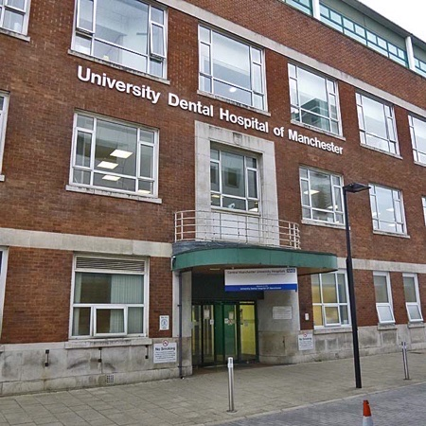

If you need to visit the dental hospital at the moment, we are here to help you and look after you.

We are doing things a bit differently to help keep you safe.

Before you come, we would like to chat with you and your parents by phone or video chat to say “Hi!”

When you arrive, you will come straight in to meet your friendly dentist and nurse.

They will be wearing special clothes like this. The special clothes help keep germs away.
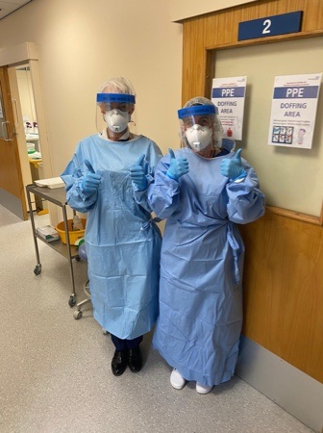
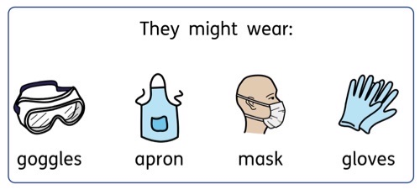
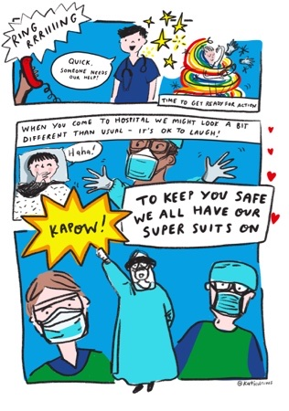

Some people think they look like superheroes when they wear this! Other people think they look like astronauts or wizards. What do you think?

Your parents will be asked to join in and wear a mask too!
Draw what you think they will look like.

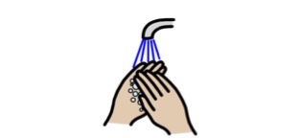

We will ask you to clean your hands with gel when you arrive.

Your dentist and nurse might look different in their special clothes. Remember they are very friendly and want to look after you.
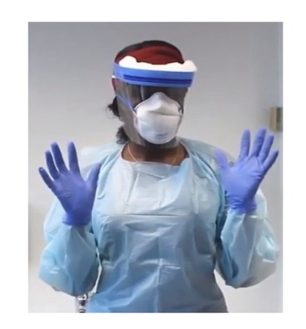
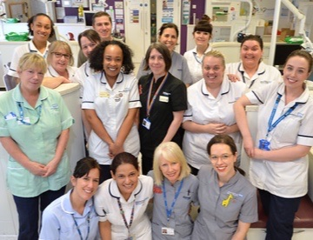

They will help you with your problem and then you can go home again.

If there is anything making you worried, or anything you would like your dentist to know before you come, you can:

- Tell your parents and they can tell us, or

- Tell the dentist on the phone when they call, or

- Write it here and bring this with you:

________________________________________________________________________________________________________________________________________________________________________________________________________________________________________________________________________________________________________________________________________________________________________________________________

Written by Sarah-Jane Snape, April 2020

Department of Child Dental Health, University Dental Hospital of Manchester, Higher Cambridge Street, Manchester, M15 6FH

