Visiting the dental hospital

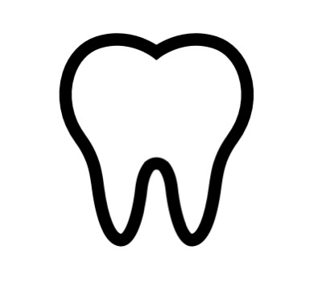If you need to visit the dental hospital at the moment, we are here to help you and look after you. This booklet explains a bit about how we are doing things a bit differently to help keep you safe.

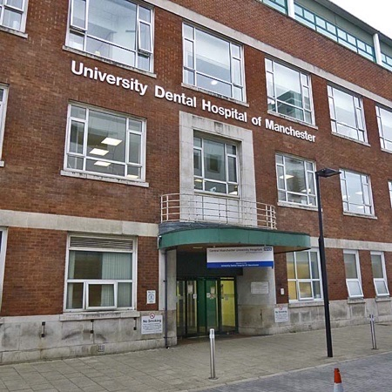

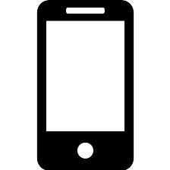Before you come, we would like to chat with you and your parents by phone or video chat to introduce ourselves and get to know about you and your dental problem before you come in.

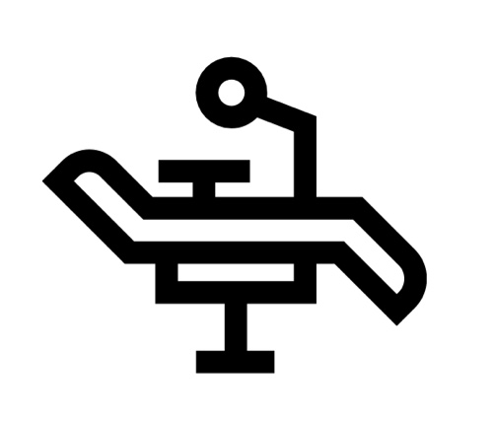When you arrive you will come straight in to meet your dentist and nurse. There won’t be much hanging around! We want to get you sorted out and on your way home as soon as we can, and we’re sure that’s what you want too!
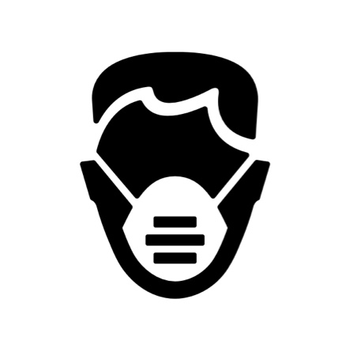
Our dentists and nurses will be wearing special, protective clothes like this. This is to protect you and others from the virus. We know it looks a bit different so please try to remember there are some friendly, helpful people under there.
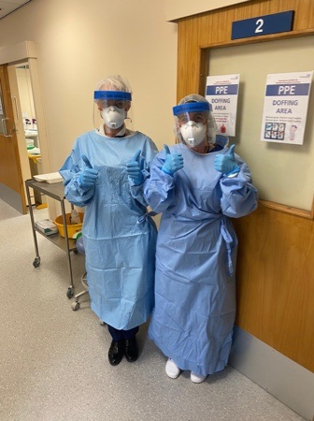

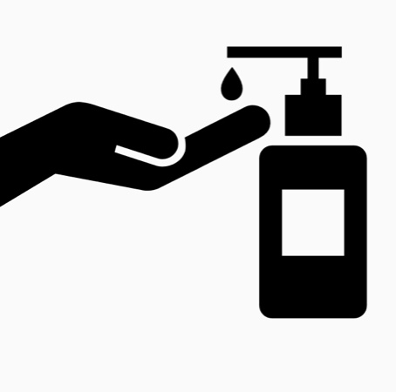
Your parents will be asked to wear a mask too. Obviously, you can’t wear one. That would make looking in your mouth a bit tricky! We will ask you to clean your hands with gel when you arrive
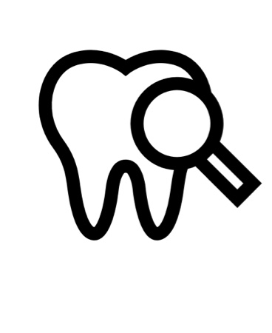

We will help you with your problem and then you can go home again.

If there is anything making you worried, or anything you would like your dentist to know before you come you can:

- Tell your parents and they can tell us, or

- Tell the dentist on the phone when they call, or

- Write it here and bring this with you: ________________________________________________________________________________________________________________________________________________________________________________________________________________________________________________________________________________________________________________________________________________________________________________________________

Written by Sarah-Jane Snape, April 2020
Department of Child Dental Health, University Dental Hospital of Manchester, Higher Cambridge Street, Manchester, M15 6FH

