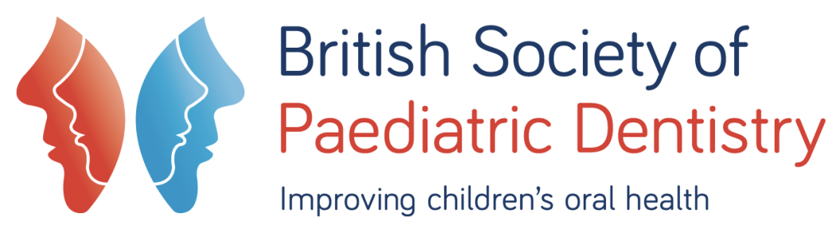
Patient Questionnaire
This sample questionnaire referenced in the document Advice for Parents of Children with Autism (http://bspd.co.uk/For-Patients) is designed for your child’s first visit to the dentist. It’s suggested that you speak to the practice or clinic to plan your child’s first visit and to ensure the questionnaire is helpful and what other information might be required.

1) Please list any specific sounds, tastes, sights or sensations that your child is sensitive to: ………………………………………………………………………………………………………………………………………………………………………………………………………………………………………………

2) Do you use communications aids e.g. Makaton /PECS/ Sentence Board or Gestures?
………………………………………………………………………………

3) Will you bring them with you? YES NO (please circle)

4) Are there any symbols/signs that we can have available to assist with communication? ..........................................................................................................................................................................................................................

5) Are there any useful phrases or words that work best with your child? ..........................................................................................................................................................................................................................
6) Does your child have any special dietary requirements? What are they?
………………………………………………………………………………………………………………………………………………………………
7) What sort of reward/reinforcer do you use with your child at home?
………………………………………………………………………………………………………………………………………………………………
8) Please list any specific behavioural challenges that you would like the dental team to be aware of. ………………………………………………………………………………………………………………………………………………………………

9) Is your child toilet trained? YES NO Nearly

10) What does your child like and dislike?
…………..............................................................................................
..........................................................................................................................................................................................................................
11) Is tooth-brushing problematic? ...........................................................................................................
………………………………………………………………………………………………………………………………………………………………
12) Please feel free to help us with any further information which may help us care for your child.
……………………………………………………………………………………………………………………………………………………………………………………………………………………………………………….

